MODULE 14 — OS COMMANDS INSIDE SNOWSQL
83. Use !system ls inside SnowSQL.
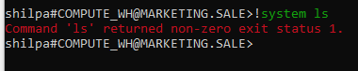
ls means shows all the files that are present inside a Snowflake stage.
Since ls is the linux command its not supported in windows OS.
Dir is the alternative command in Windows OS for ls.
After executing !system dir, the following is the result.
Why to use system dir List the files inside your local computer directory
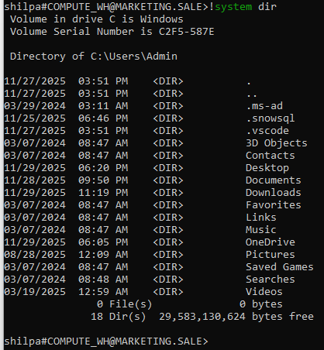

84. Use !system pwd.
Pwd is the linux command to print working directory
It is not supported in windows
After executing cd command is the following result

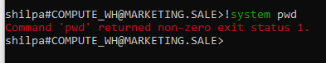
cd is to print the current directory
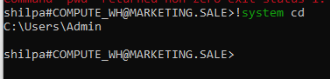

85. Change directory inside SnowSQL shell.
Its not working for me
I used the command change directory it’s not working I need your help
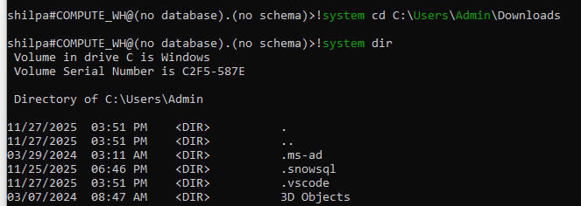

86. List files in the current directory.
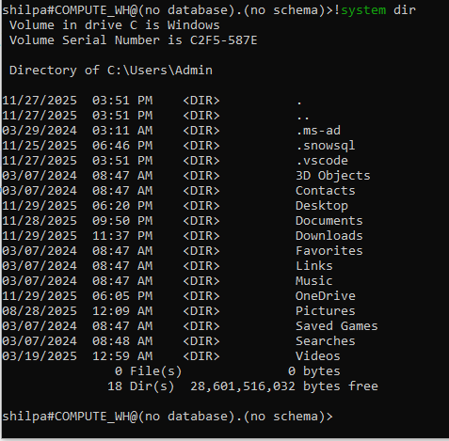

MODULE 15 — EXPORTING DATA (UNLOAD)
87. Export data from a table to a stage.
COPY INTO @stage_accounting/export/
FROM departments
FILE_FORMAT = (TYPE = CSV COMPRESSION = NONE);

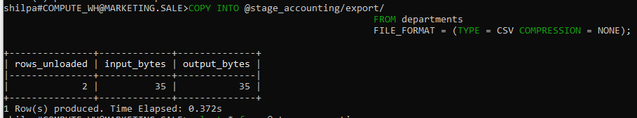

88. Export only one column to CSV.
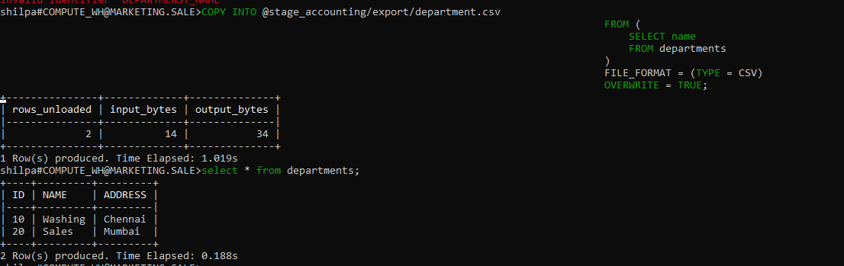
89. Export JSON data using JSON format.
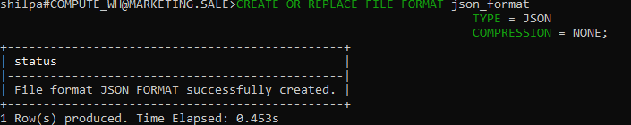
90. Export with OVERWRITE=TRUE.
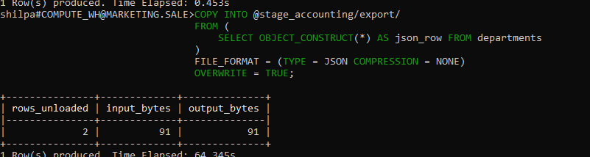
91. Export query results into multiple CSV files (partitioned).

92. Download exported data via GET.
Fetching the data from snowflake table and downloading the files into the local system
